EXP 01:

AIM: Write a C program to simulate a Deterministic Finite Automata (DFA) for the given language representing strings that start with a and end with a

ALGORITHM:

#include <stdio.h>

#include <string.h>

// Define the number of states in the DFA

#define NUM_STATES 2

// DFA transition table

int transitionTable[NUM_STATES][2] = {

{1, 0}, // State 0: Starting state (on input 'a', transition to state 1; on input 'b', stay in state 0)

{1, 1} // State 1: Accepting state (on any input, stay in state 1)

};

// Function to simulate the DFA

int simulateDFA(char *inputString) {

int currentState = 0; // Initial state is 0

int inputLength = strlen(inputString);

for (int i = 0; i < inputLength; i++) {

char inputChar = inputString[i];

if (inputChar != 'a' && inputChar != 'b') {

return 0; // Invalid input character, return failure

}

int inputIndex = inputChar - 'a'; // Map 'a' to 0, 'b' to 1

currentState = transitionTable[currentState][inputIndex];

}

return currentState == 1; // Return 1 if the final state is accepting, otherwise 0

}

int main() {

char inputString[100]; // Assuming input string length won't exceed 100 characters

printf("Enter an input string: ");

scanf("%s", inputString);

if (simulateDFA(inputString)) {

printf("String is accepted.\n");

} else {

printf("String is not accepted.\n");

}

return 0;

}

OUTPUT:

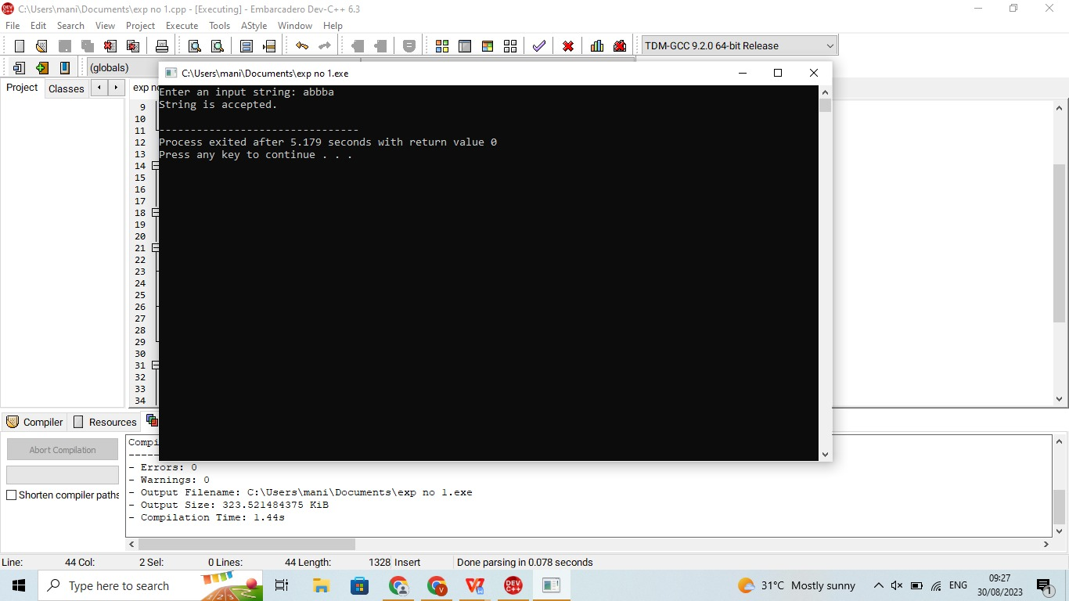

OUTPUT:The program successfully executed in devc++